 AFIKE TECHNOLOGIES LIMITED
Product name | Aifike  model | Product images | VIP Price | Wholesale  Price
DRY IRON BOX | AFK-101 | 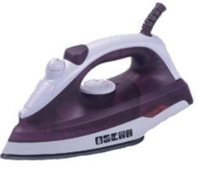 | 1230 | 1370
DRY IRON BOX | AFK-102 | 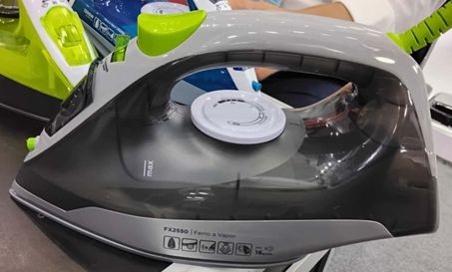 | 1870 | 2080
TOASTER | AFK-103 | 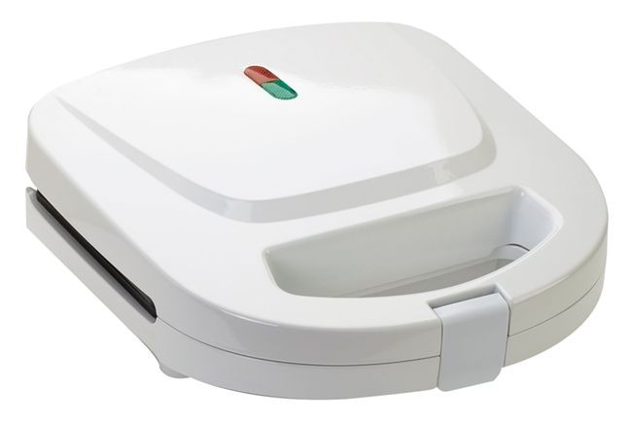 | 1260 | 1400
HOT AIR COMB | AFK-104 | 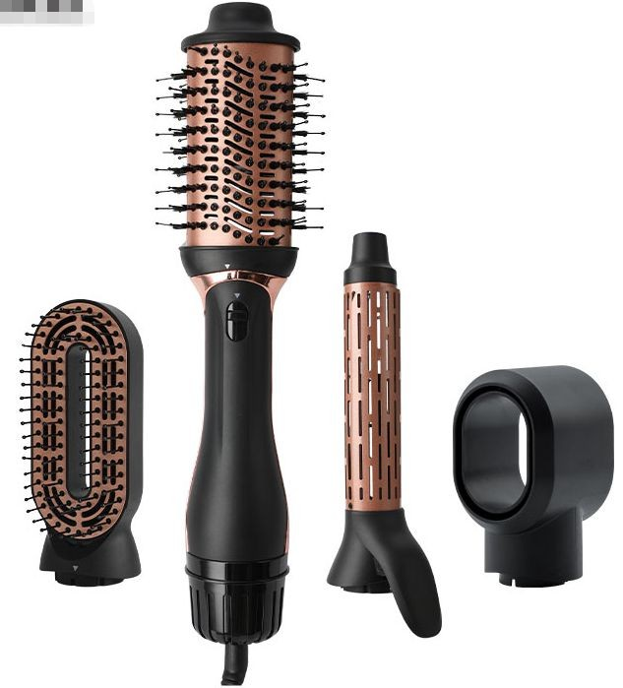 | 2750 | 3060
WATER DISPENSER | AFK-105 | 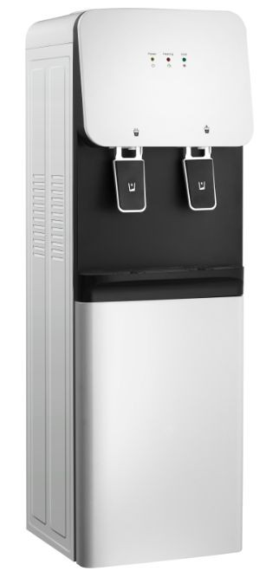 | 7990 | 8880
RICE COOKER | AFK-132 | 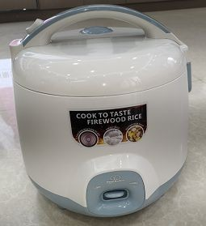 | 3220 | 3500
FAN | AFK-135 | 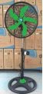 | 2310 | 2570
MICROWAVE 20LTS | AFK-129 | 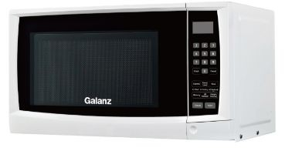 | 7920 | 9000

-
INDUCTION COOKER | AFK-128 | 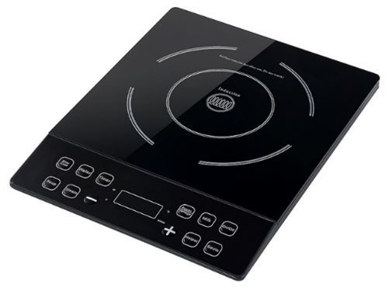 | 4760 | 5290
GAS STOVER | AFK-130 | 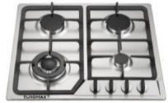 | 13550 | 15060
COOKWARE | AFK-133 | 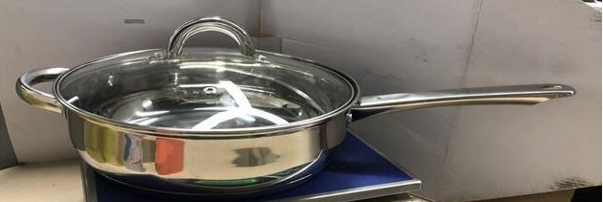 | 2070 | 2300
FREEZER 105LTS | AFK-137 | 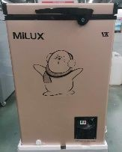 | 21660 | 24070
ELECTRIC PRESSURE COOKER | AFK-136 | 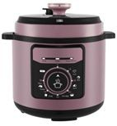 | 4720 | 5240
Gas stovesGAS 2 BURNER | AFK-124 | 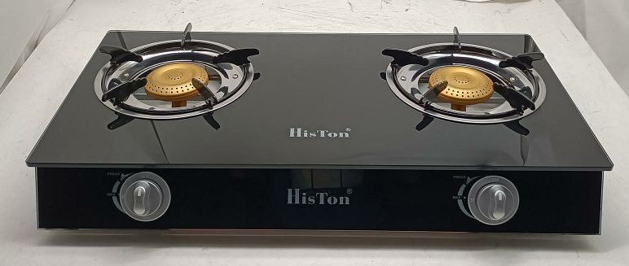 | 3270 | 3630
GAS 3 BURNER | AFK-125 | 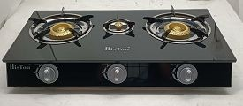 | 4280 | 4750
BLENDER 1.8LTS | AFK-126 | 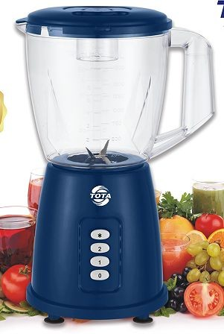 | 2150 | 2390
OVEN 45LTS | AFK-123 | 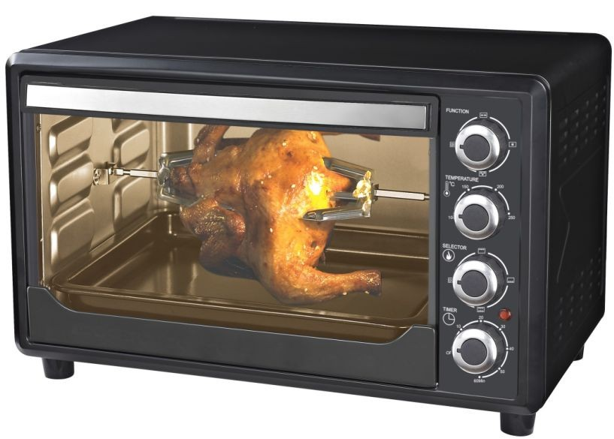 | 9280 | 10310
EGGBEATER | AFK-127 | 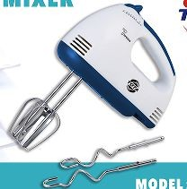 | 1100 | 1220

VACUUM CLEANER 21LTS | AFK-116 | 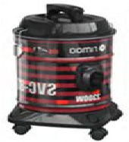 | 8140 | 9040
AIR FRYER 6LTS | AFK-117 | 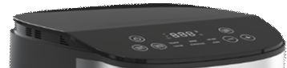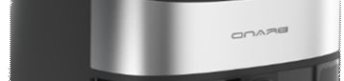 | 8070 | 8970
ELECTRIC KETTLE 1.8LTS | AFK-121 | 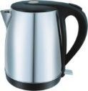 | 1830 | 2080
ELECTRIC KETTLE 1.8LTS | AFK-122 | 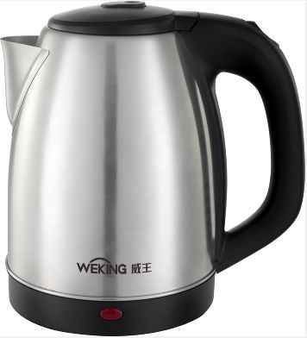 | 1230 | 1430
OVEN 30LTS | AFK-118 | 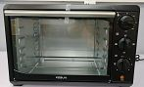 | 6440 | 7150
ELECTRIC WATER BOTTLE  PUMP | AFK-108 | 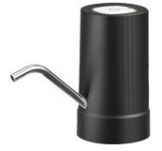 | 450 | 500
COFFEE MACHINE | AFK-107 | 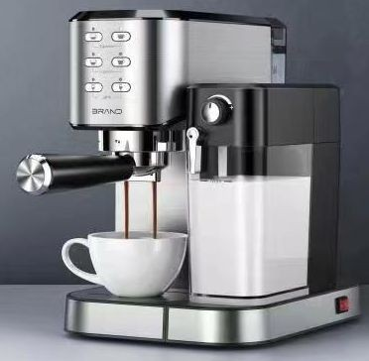 | 24010 | 26680
ELECTRIC PRESSURE COOKER | AFK-112 | 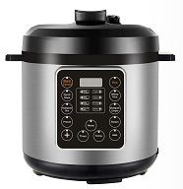 | 6130 | 6810
ELECTRIC PRESSURE COOKER | AFK-113 | 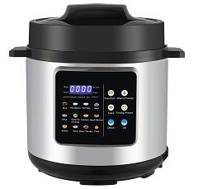 | 6480 | 7200
MANUAL PRESSURE COOKER | AFK-106 | 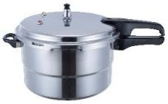 | 3290 | 3650

HAND-HELD FAN | AFK-110 | 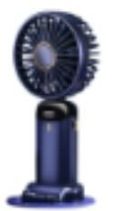 | 460 | 510
PORTABLE FAN | AFK-111 | 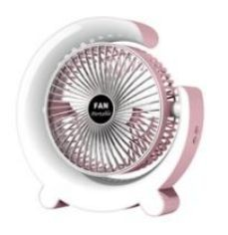 | 770 | 860
SOLAR FAN | AFK-114 | 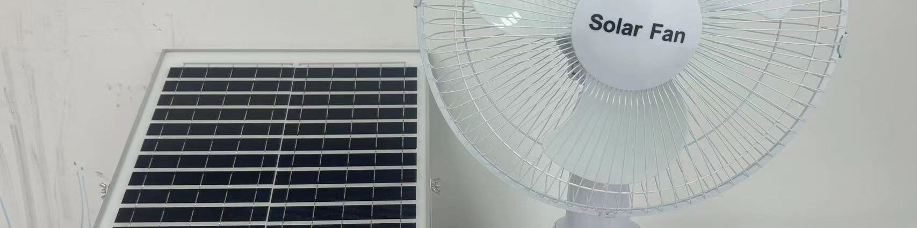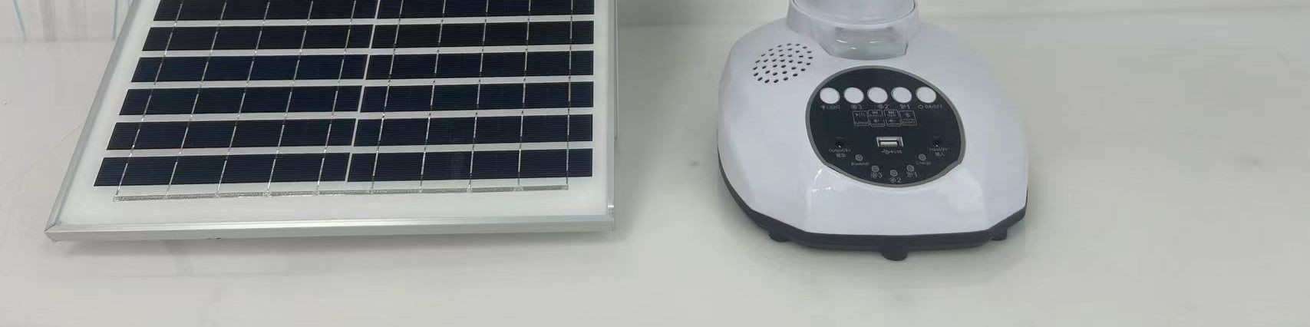 | 3240 | 3600
BEATER | AFK-109 | 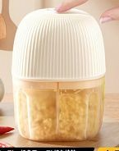 | 510 | 570
BLENDER 1.5LTS | AFK-115 | 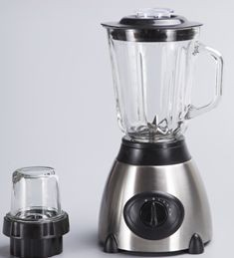 | 3080 | 3420
EXTENSION 5 SOCKET | AFK-249 | 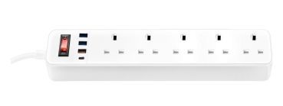 | 1590 | 1770
Water Heater | AFK-214 | 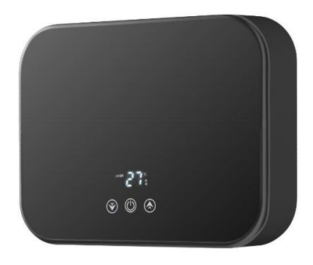 | 8140 | 9040

Remarks:
* All price inclusive VAT, all the order should give out VAT, if customer insist no need VAT, we can upmost give 3% discount

